**ASSIGNMENT-1**

NAME: M.Ravi Sai Vinay

REG-NO: 192311035

SUBJECT: Python

CODE: CSA0898

1.Converting Roman Numbers to integers?

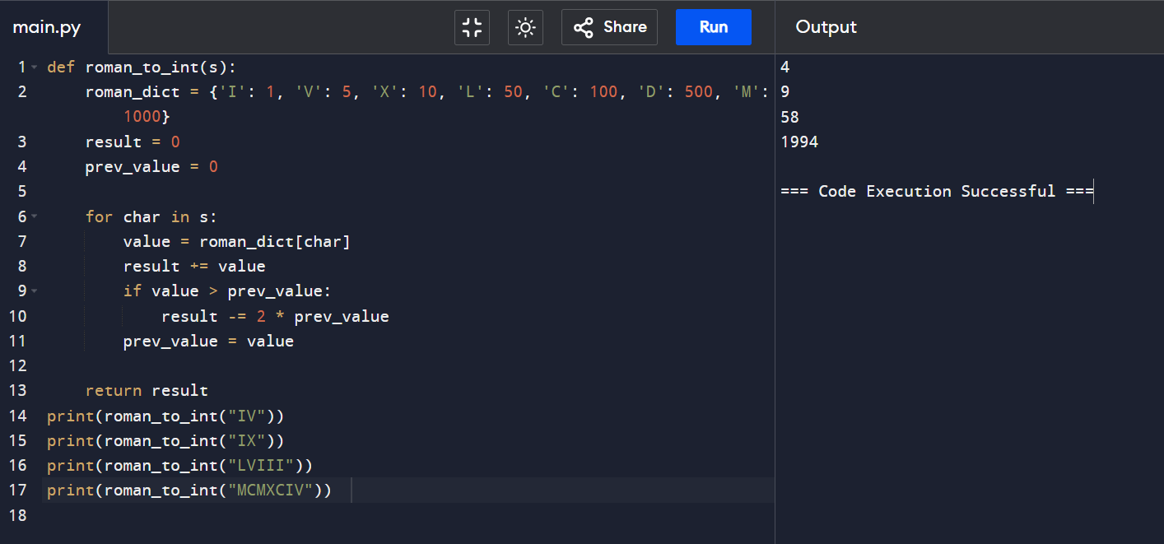

2.

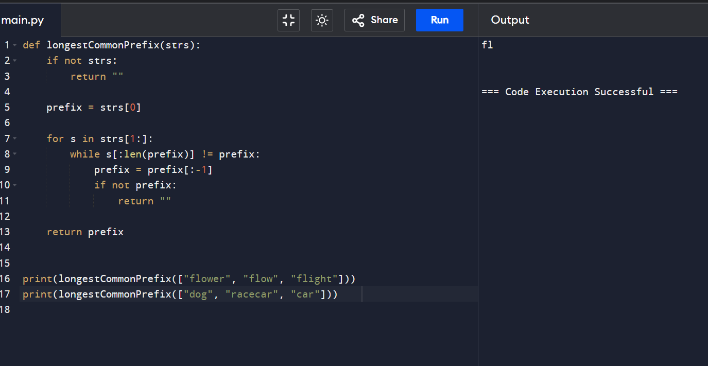

3.

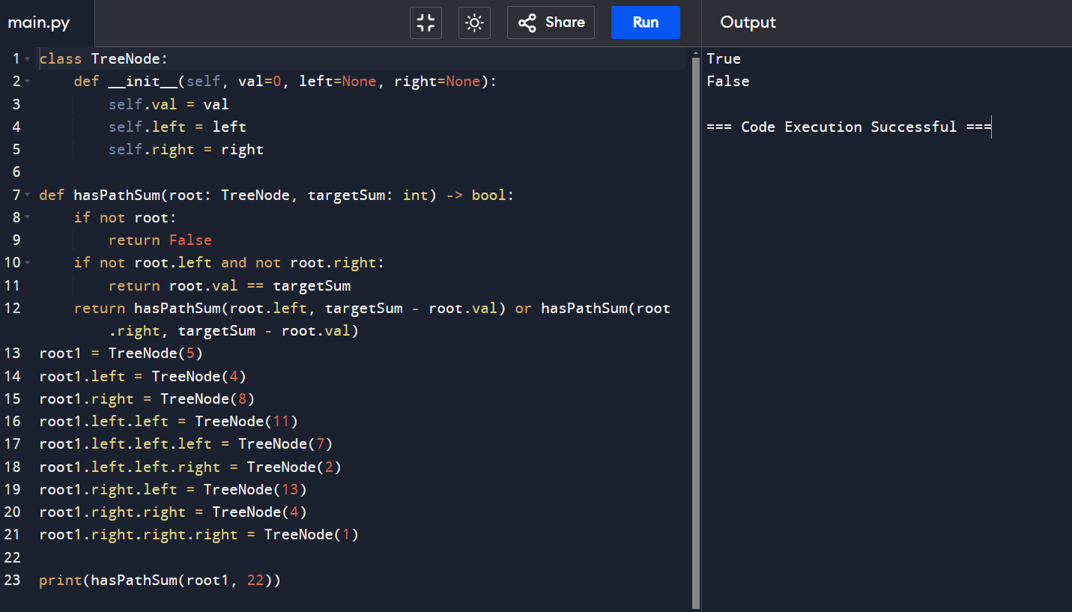

4. Given the root of a binary tree and an integer of targetsum return true if the tree has a root to leaf such that adding up all the values

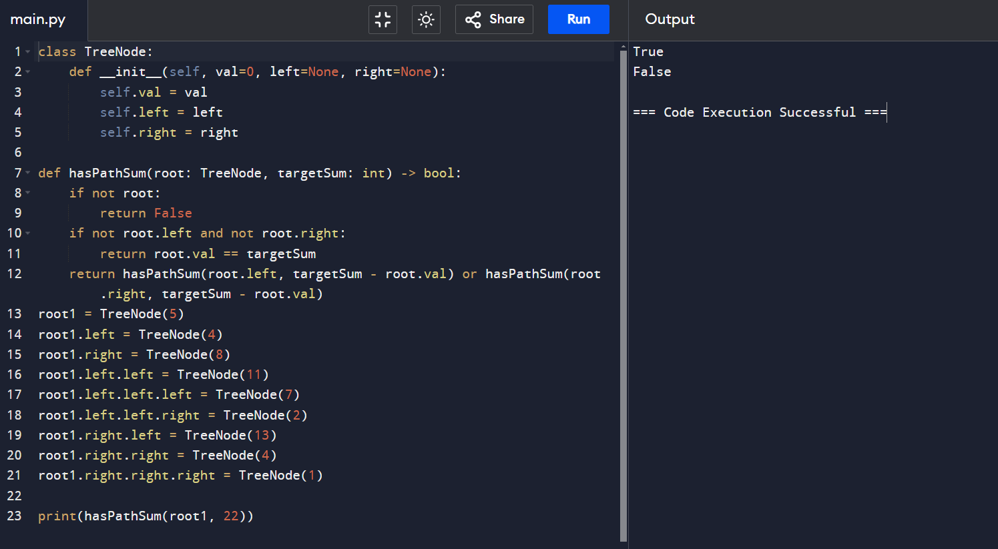

5.bit reversing?

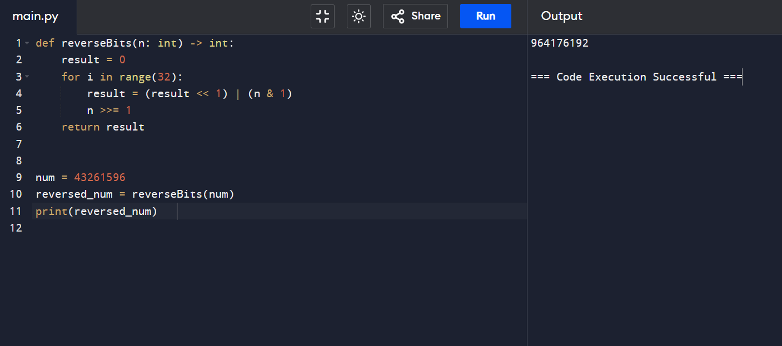

6. convert sorted array to binary search tree?

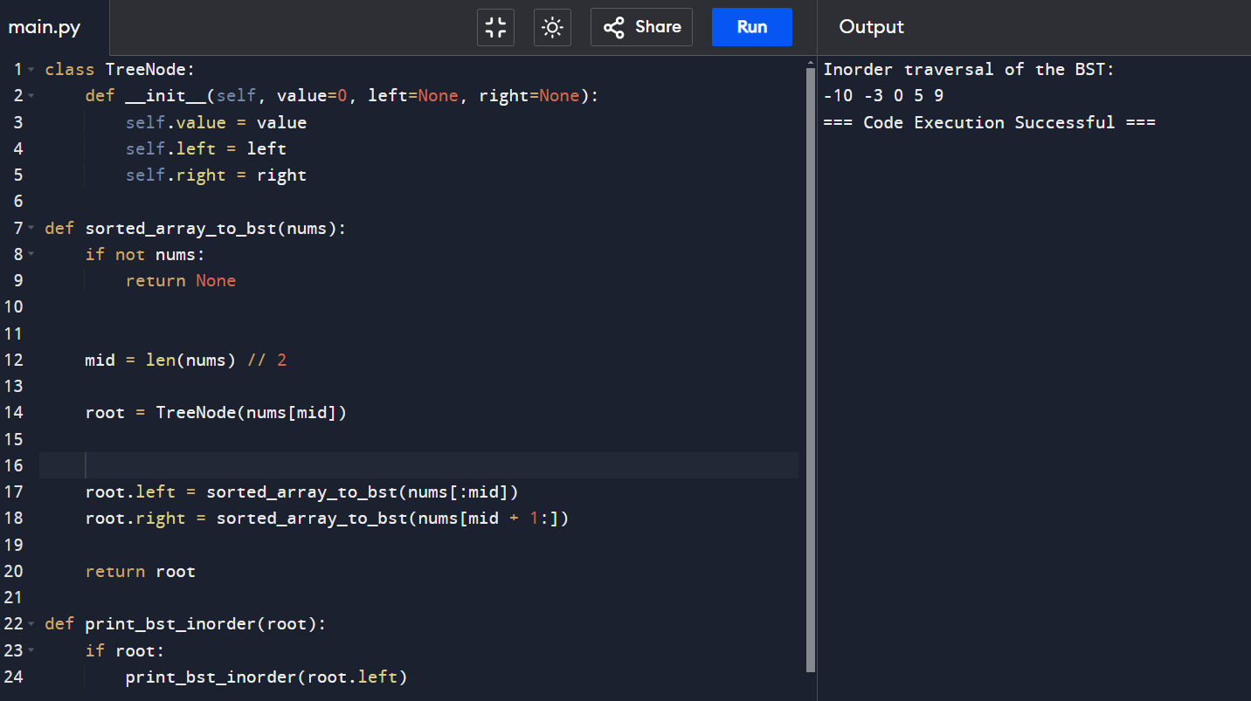

7. given a binary tree, determine if it is height-balanced?

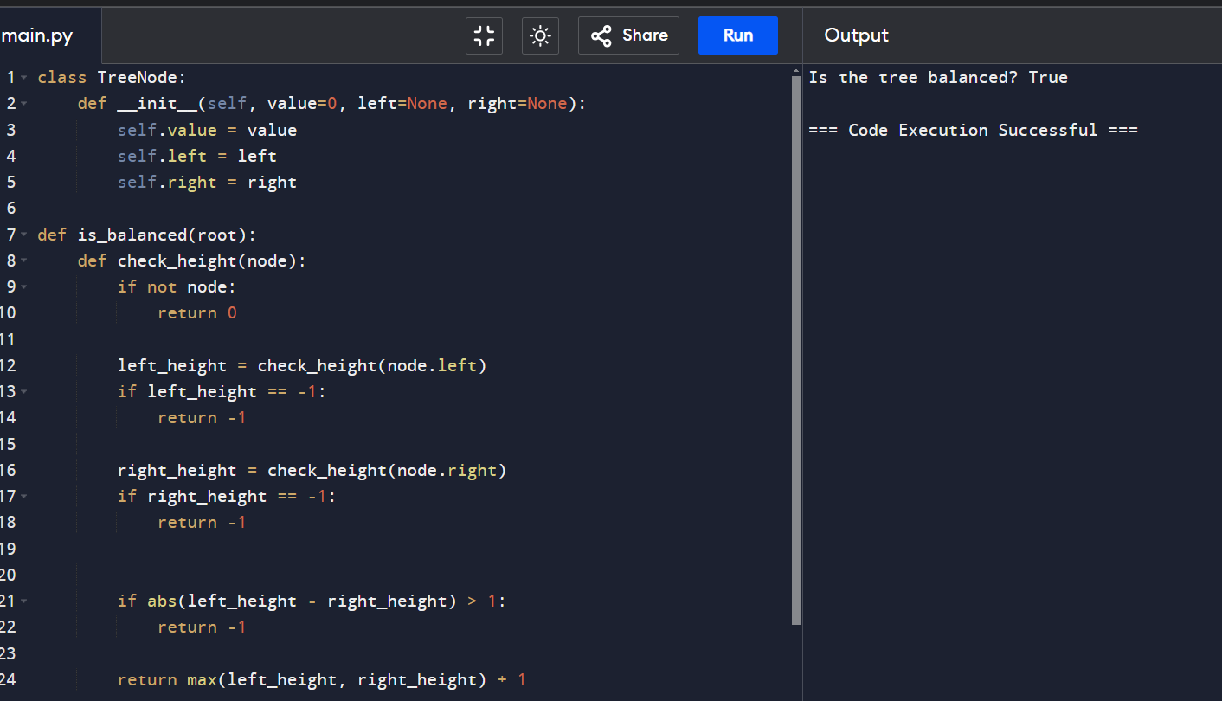

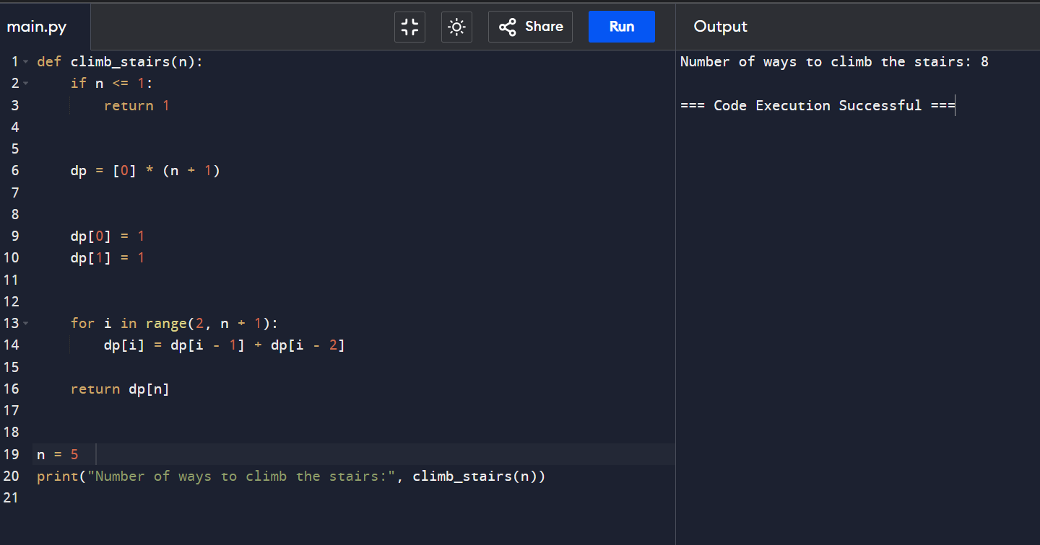8. Climbing stairs?

9. best time to buy and sell stock?

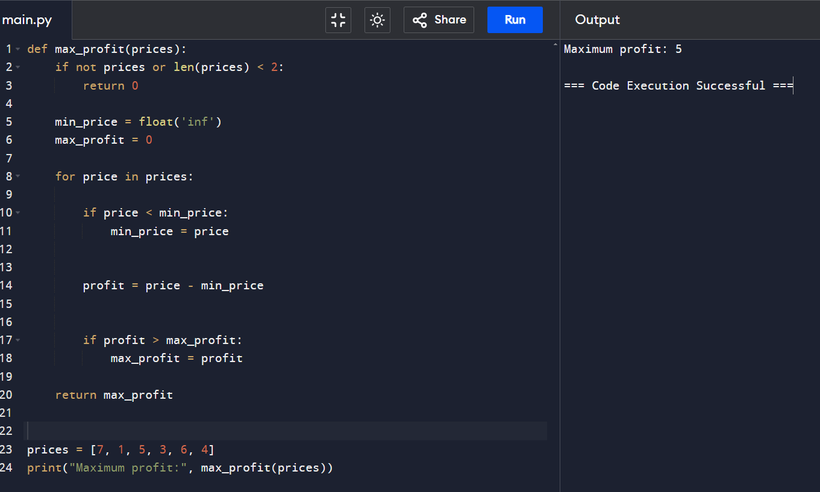

10.sum of two binary strings?

